60：

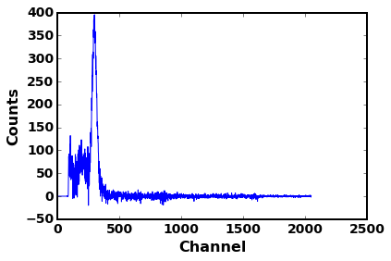

[[Model]]

Model(gaussian)

[[Fit Statistics]]

# fitting method = leastsq

# function evals = 28

# data points = 202

# variables = 4

chi-square = 148371.65296

reduced chi-square = 749.35178

Akaike info crit = 1341.03999

Bayesian info crit = 1354.27306

[[Variables]]

amp: 337.064965 +/- 6.357446 (1.89%) (init= 3000)

cen: 295.664275 +/- 0.356966 (0.12%) (init= 300)

wid: 17.1197771 +/- 0.402831 (2.35%) (init= 15)

const: 35.9780149 +/- 2.598693 (7.22%) (init= 100)

[[Correlations]] (unreported correlations are < 0.100)

C(wid, const) = -0.463

C(amp, wid) = -0.356

C(amp, const) = -0.289

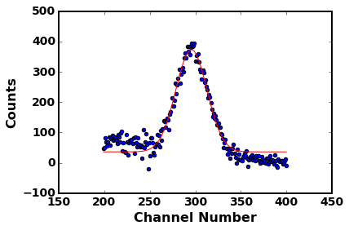

90：

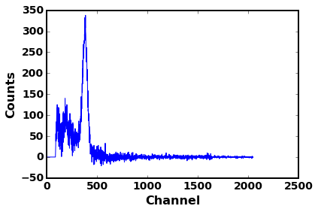

[[Model]]

Model(gaussian)

[[Fit Statistics]]

# fitting method = leastsq

# function evals = 38

# data points = 152

# variables = 4

chi-square = 54851.33284

reduced chi-square = 370.61711

Akaike info crit = 903.05219

Bayesian info crit = 915.14771

[[Variables]]

amp: 268.799800 +/- 4.429087 (1.65%) (init= 3000)

cen: 376.436450 +/- 0.361975 (0.10%) (init= 375)

wid: 22.6368091 +/- 0.531482 (2.35%) (init= 15)

const: 31.5346694 +/- 3.332895 (10.57%) (init= 100)

[[Correlations]] (unreported correlations are < 0.100)

C(wid, const) = -0.732

C(amp, const) = -0.542

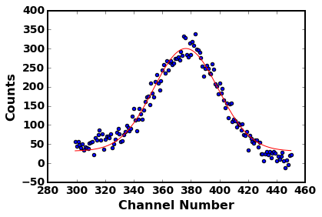

105：

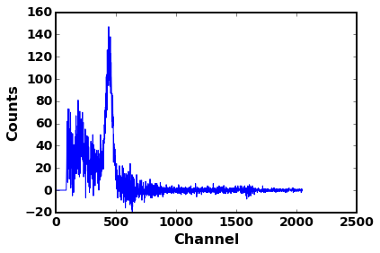

[[Model]]

Model(gaussian)

[[Fit Statistics]]

# fitting method = leastsq

# function evals = 38

# data points = 300

# variables = 4

chi-square = 46021.09460

reduced chi-square = 155.47667

Akaike info crit = 1517.92180

Bayesian info crit = 1532.73693

[[Variables]]

amp: 109.961455 +/- 2.359528 (2.15%) (init= 3000)

cen: 438.890049 +/- 0.612488 (0.14%) (init= 450)

wid: 25.8539332 +/- 0.693486 (2.68%) (init= 15)

const: 11.1860540 +/- 0.978092 (8.74%) (init= 100)

[[Correlations]] (unreported correlations are < 0.100)

C(wid, const) = -0.469

C(amp, wid) = -0.350

C(amp, const) = -0.293

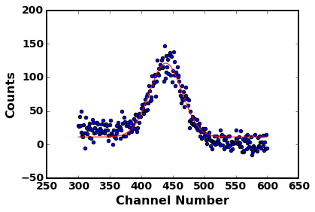

120

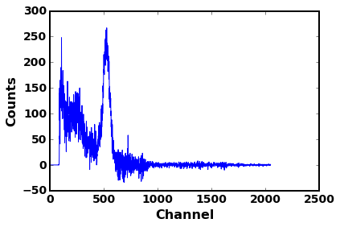

[[Model]]

Model(gaussian)

[[Fit Statistics]]

# fitting method = leastsq

# function evals = 38

# data points = 251

# variables = 4

chi-square = 87581.11789

reduced chi-square = 354.57942

Akaike info crit = 1477.57181

Bayesian info crit = 1491.67362

[[Variables]]

amp: 218.878796 +/- 3.459369 (1.58%) (init= 3000)

cen: 521.230933 +/- 0.499595 (0.10%) (init= 510)

wid: 29.8881056 +/- 0.626626 (2.10%) (init= 15)

const: 16.3843126 +/- 1.960976 (11.97%) (init= 100)

[[Correlations]] (unreported correlations are < 0.100)

C(wid, const) = -0.604

C(amp, const) = -0.401

C(amp, wid) = -0.179

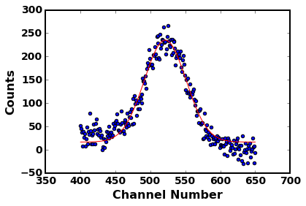

135

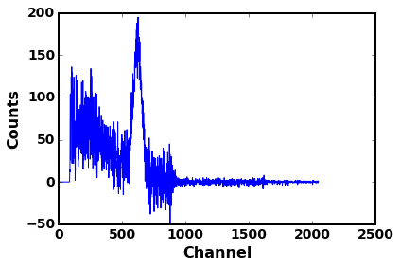

[[Model]]

Model(gaussian)

[[Fit Statistics]]

# fitting method = leastsq

# function evals = 43

# data points = 251

# variables = 4

chi-square = 70788.77399

reduced chi-square = 286.59423

Akaike info crit = 1424.14269

Bayesian info crit = 1438.24451

[[Variables]]

amp: 151.812021 +/- 3.046886 (2.01%) (init= 3000)

cen: 618.661336 +/- 0.676771 (0.11%) (init= 600)

wid: 32.6407906 +/- 0.891327 (2.73%) (init= 15)

const: 11.9360579 +/- 1.916592 (16.06%) (init= 100)

[[Correlations]] (unreported correlations are < 0.100)

C(wid, const) = -0.651

C(amp, const) = -0.447

C(amp, wid) = -0.101

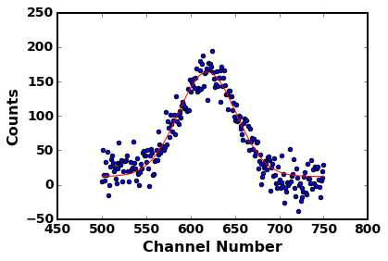

150

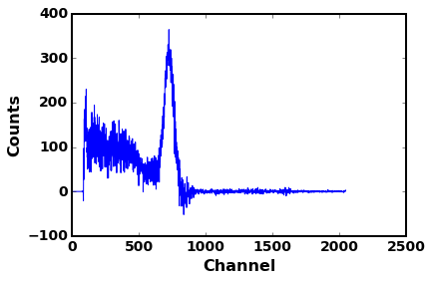

[[Model]]

Model(gaussian)

[[Fit Statistics]]

# fitting method = leastsq

# function evals = 43

# data points = 251

# variables = 4

chi-square = 170827.99818

reduced chi-square = 691.61133

Akaike info crit = 1645.26284

Bayesian info crit = 1659.36465

[[Variables]]

amp: 297.687880 +/- 4.693518 (1.58%) (init= 3000)

cen: 723.855432 +/- 0.562523 (0.08%) (init= 725)

wid: 35.9311940 +/- 0.796791 (2.22%) (init= 15)

const: 12.8577506 +/- 3.348226 (26.04%) (init= 100)

[[Correlations]] (unreported correlations are < 0.100)

C(wid, const) = -0.708

C(amp, const) = -0.510

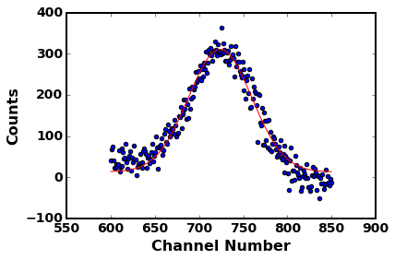

165

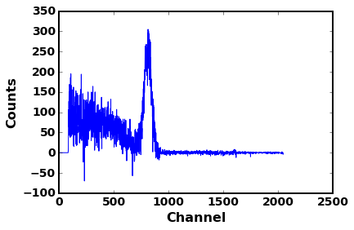

[[Model]]

Model(gaussian)

[[Fit Statistics]]

# fitting method = leastsq

# function evals = 38

# data points = 176

# variables = 4

chi-square = 139046.57012

reduced chi-square = 808.41029

Akaike info crit = 1182.28611

Bayesian info crit = 1194.96805

[[Variables]]

amp: 253.141283 +/- 7.133331 (2.82%) (init= 3000)

cen: 810.928924 +/- 0.682787 (0.08%) (init= 825)

wid: 32.6702468 +/- 1.345317 (4.12%) (init= 15)

const: 8.40668105 +/- 7.073054 (84.14%) (init= 100)

[[Correlations]] (unreported correlations are < 0.100)

C(wid, const) = -0.859

C(amp, const) = -0.766

C(amp, wid) = 0.468

